## EXPERIMENT 7

**AIM:** Write a program to generate a square wave using µp 8086 interfaced with PPI8255 and execute the same.

**THEORY:**

8255 is a programmable peripheral interfacing IC which contains 3 I/O ports which can be programmed in different modes. To program the function to all three I/O ports,it contains a register called control register. The control register gives the signal which is used to define the function of each I/O port and in which mode they should operate.Port A, Port B and Port C are 8-bit ports. 8255 has direct bit select/reset compatibility which is available for Port C [BSRmode]. The ports can be operated in 3modes.

Mode 0- Simple I/O, Mode1-Strobbed I/O

Mode2-Strobbed bidirectional I/O.

# I/OmodeControl Word Format

# 

The Bit Set/Reset (BSR) mode is applicable to port C only. Each line of port C (PC0 -PC7) can be set/reset by suitably loading the control word register. BSR mode and I/Omode are independent and selection of BSR mode does not affect the operation ofotherports inI/O mode.

# 

|  |  |  |  |
| --- | --- | --- | --- |
| B3 | B2 | B1 | Bit/Pin of PortC Selected |
| 0 | 0 | 0 | PC0 |
| 0 | 0 | 1 | PC1 |
| 0 | 1 | 0 | PC2 |
| 0 | 1 | 1 | PC3 |
| 1 | 0 | 0 | PC4 |
| 1 | 0 | 1 | PC5 |
| 1 | 1 | 0 | PC6 |
| 1 | 1 | 1 | PC7 |

**ALGORITHM**:

MAINPROGRAM

1. Load Control Word Format of8255.
2. Set the selected bit of port C.
3. Call the delay subroutine.

### 

1. Reset the selected bit of port C.
2. Call the delay subroutine.
3. Terminate the program.

DELAY SUBROUTINE

1. Load count in BLregister.
2. Load count in CLregister.
3. Decrement count value in CL register.
4. If CL≠0then goto stepno.3.
5. Decrement count value in BL register.
6. If BL≠0then gotostepno.2

Return to the main Program

Program :

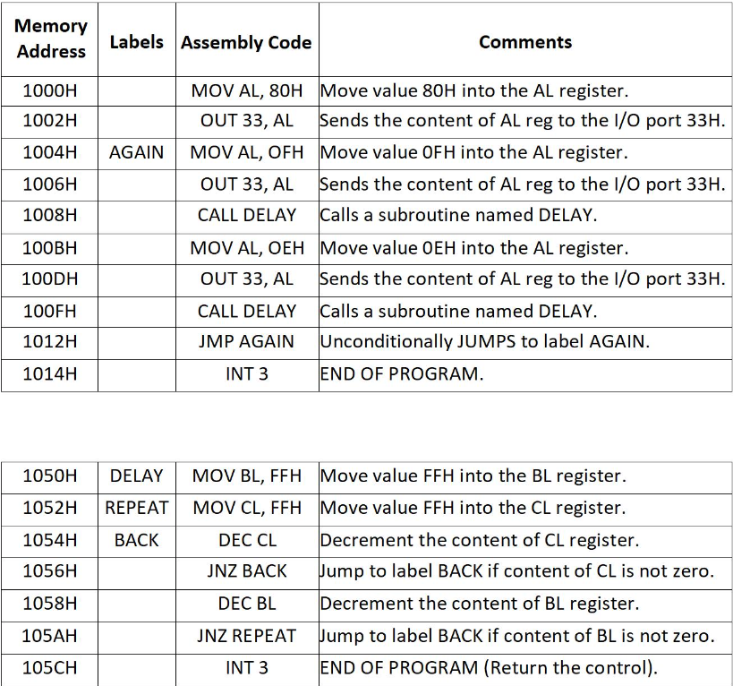

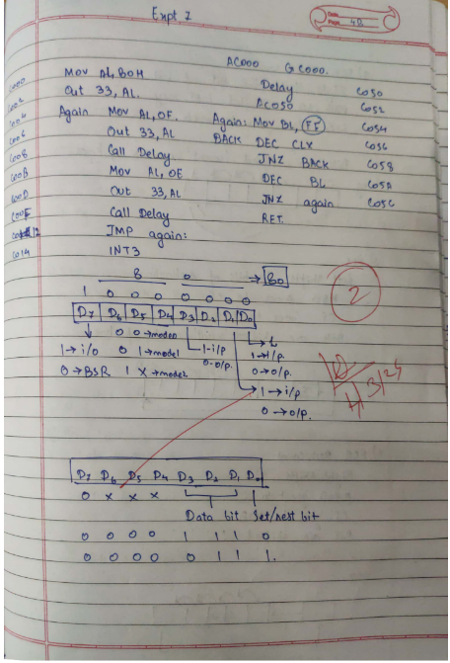

**CONCLUSION**: Hence, we executed an ALP to generate a square wave using µp 8086 interfaced with PPI8255.

Name :Abdullah Khan

Roll No: 122A1002 --(02)

Batch :C1 Batch